

**Technical Details Document of**

**TDS Process**

Submitted Date: Date of Submission

Submitted Date: 16th October 2023

Proposal ID: AHA/RPA/

**Ahana Systems and Solutions Private Limited**

**# 502/37, 2nd Floor, 1st Main, 40th Cross, 8th Block Jayanagar, Bengaluru -560011**

[www.ahanait.com](http://www.ahanait.com)

**Contact: Manmohan Kumar Tiwari**

**Email ID: manmohan.tiwari@ahanait.com**

**Phone: 8553640065**

# Contents

1 Contents 2

2 Document Revision History 3

3 About Ahana Systems 4

**3.1** Ahana – Company Overview 4

**3.2** Ahana – Differentiators 4

4 Introduction 5

**4.1** Background 5

5 Scope of Work 5

6 PROCESS UNDERSTANDING 5

**6.1** **PRE-REQUISITE** 5

**6.2** **TDS – PROCESS STEPS** 6

**6.3** **FLOWCHARTS** 11

# Document Revision History

|  |  |  |  |
| --- | --- | --- | --- |
| **Revision Number** | **Revision Date** | **Nature of Revision** | **Authored By** |
| 1 |  | TDS Process | Rajesh S |
|  |  |  |  |
|  |  |  |  |

# About Ahana Systems

## Ahana – Company Overview

Ahana has an industry presence of over 10 years with an employee and consultant strength exceeding 450.

The team at Ahana is highly experienced and qualified in the space of IT Infrastructure Management and Digital Transformation Services. This team is driven by the vision and leadership of our senior management which has over 200 person years of industry experience.

Visit [www.ahana.co.in](http://www.ahana.co.in) for further information about Ahana.

**We Specialize in:**

|  |  |
| --- | --- |
| IT Infrastructure Managed Services | Data Centre, Cloud, Network & Security, End User Computing, DevOps, Service Desk – Remote and Onsite Monitoring and Delivery Models |
| Digital Transformation Services | Databases and EDW, SAP S/4 HANA, Big data, BI & Analytics, Application Development and Maintenance, UX and Web services, ERP Services, FMS Automation, Robotic Process Automation |

## Ahana – Differentiators

* “10 Most Promising Managed Cloud Service Providers”- **Silicon India Dec 2019**
* “10 Most Promising Cloud Migration Solution Providers 2019” – **CIO Review 2019 and 2021**
* 20 Most Promising SAP solution providers in India – CIO Review
* 20 Most Promising SAP solution providers in India – Insight Success
* 20 Most promising Microsoft solution providers in India – CIO Review
* SAP ACE 2015 award winner in the category "Enterprise Analytics”
* ISO 9K & ISO 27K certified company
* Microsoft Gold Partner for DC, Cloud Productivity and Cloud Solutions
* SAP partner for Data Management
* Cost effective, Consistent, Enhanced service delivery with ITIL framework ™
* Business driven solution & flexibility to execute / scale
* Strategic Partnership with key product vendors
* Improved ROI
* Business aligned support services
* Enhanced user experience
* Consistent and reliable delivery

# Introduction

## Background

Ahana is proposing to automate this process by using RPA UiPath.

# Scope of Work

The scope of requirement is based on the demo given by Ahana for the TDS process , steps and further detailing done for the process activity under section 3 of this document.

# PROCESS UNDERSTANDING

## **PRE-REQUISITE**

* Access to Zoho Website.
* Access to Outlook.
* Access to Excel.

## **SERVICE LEVEL REPORT – PROCESS STEPS**

This process will download TDS reports for the previous month and Quarterly basis consolidate reports according to the required format and share them through e-mail

• Automation of this process activity involves Downloading various TDS summary reports, consolidating them as per the standard format provided and sharing it through email.

• Downloading Balance Sheet TDS reports, consolidating them as per the standard format provided and sharing it through email.

### Downloading TDS Summary from Zoho Portal

1. login to Zoho Portal, In Left Hand Navigation bar Click on Reports Button, Reports page containning various reports will be diaplayed.

2. Click TDS summary link under Taxes menu.

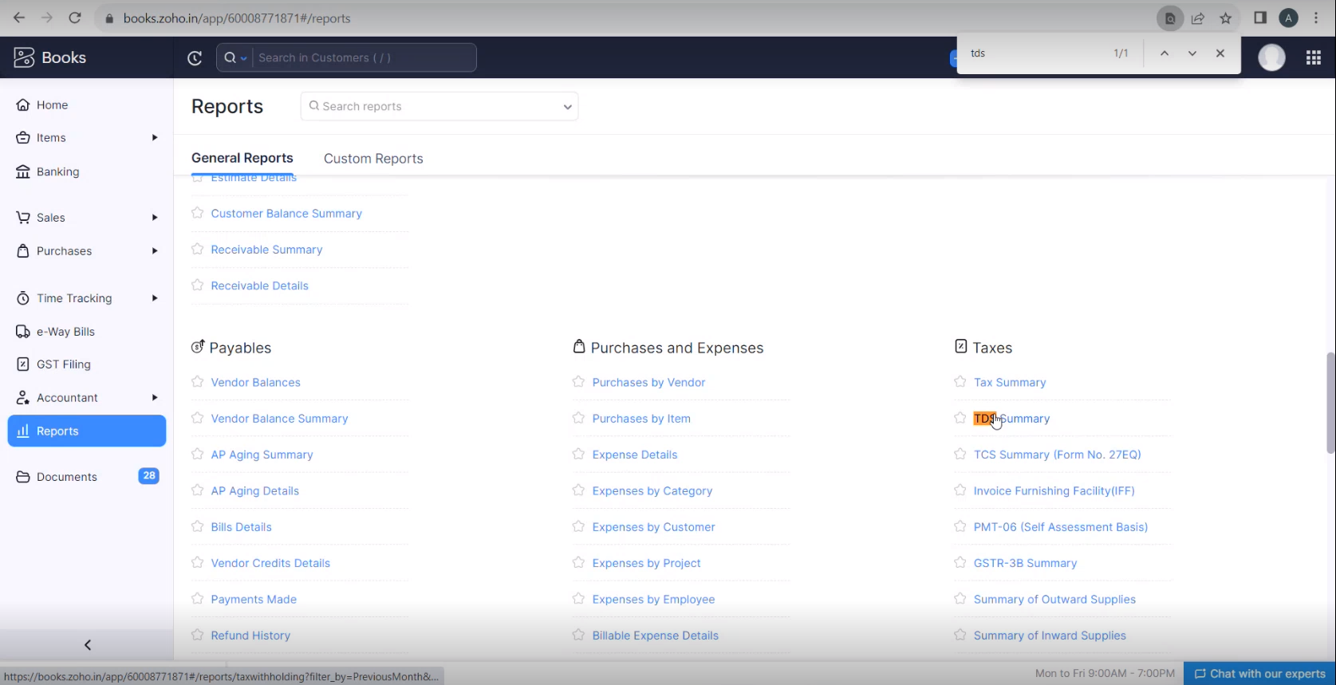

3. Select previous month from the this month dropdown.(This will be changed to this quarter while generating reports on Quaterly basis ). it will displays all the reports links.

4. Under TDS section, click on the section link. ( for Section 194C, Section 194I and Section 194J), It will be display Report details.

5. Click on Export as and export the data (download report).

(Note : The Report data has to be exported for all Sections links)

6. Fetch the downloaded reports and format them according to the template provided. (Different sections will be updated in the section column)

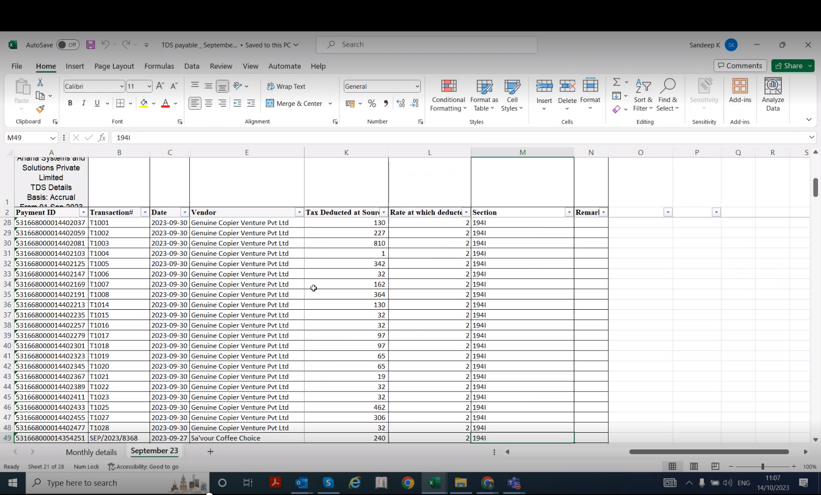

7. Once the Reports are consolidated share it to the respective authorities through mail.

### Downloading balance sheet TDS reports from Zoho Portal

1. login to Zoho Portal, In Left Hand Navigation bar Click on Reports Button, Reports page containing various reports will be diaplayed.

2. In Reports page, Click on Balance Sheet link under Business Overview menu.

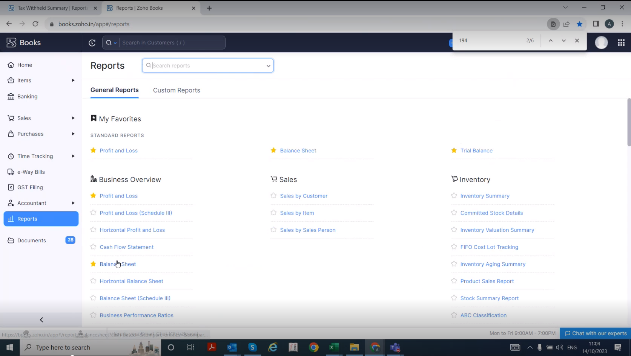

3. Select previous month from the this month dropdown.(This will be changed to this/previous quarter while generating reports on Quaterly basis ). Search for TDS in the webpage and click on TDS dropdown, it will diaplays all the report file links.

4. Click on the links under TDS menu, it will navigate to reports page and click on export and export the data(download the data).

5. Once the all the reports downloaded, consolidate data according to the provided template.

6. share the consolidated report file through the respective authorities through the mail.

## **FLOWCHARTS**

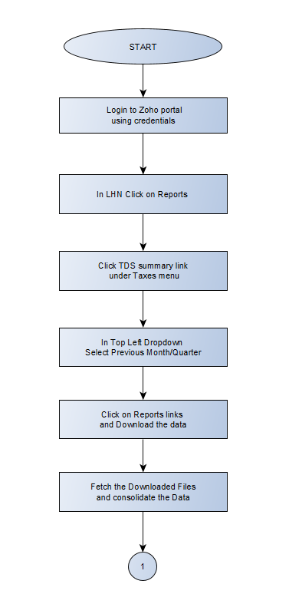

Fig 2: Downloading and consolidating Balance Sheet reports and Sending Both reports through mail

Fig 1: Downloading and consolidating TDS reports